H.T.NO:2303A51656
Batch 28
Problem Statement 1:
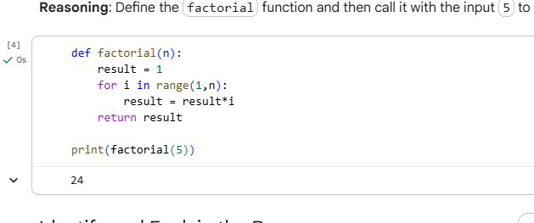
Identify and Explain the Bug
Subtask:
Analyze the factorial function's logic to pinpoint the bug, specifically the off-by-one error in the range function, and explain why it leads to incorrect results.

Bug Analysis and Explanation
- Examining the factorial function definition:
- def factorial(n):
result = 1
for i in range(n):
result *= i
return result
- Focusing on for i in range(n): when n=5: When n=5, the range(5) function generates a sequence of numbers starting from 0 up to (but not including) 5. So, i will take on the values 0, 1, 2, 3, 4.
- Identifying the first value i takes in the loop: The first value i takes in the loop is 0.
- Explaining how multiplying result by this first value immediately causes the function to return 0: In the first iteration of the loop, result (which is initially 1) is multiplied by i, which is 0. So, result becomes 1 * 0 = 0. Once result becomes 0, any subsequent multiplications within the loop (e.g., 0 * 1, 0 * 2, etc.) will keep result at 0. Therefore, the function will always return 0 for any n > 0.
- Describing the correct sequence of multiplications for a factorial calculation: For factorial(5), the correct calculation should be 5 * 4 * 3 * 2 * 1, which equals 120. If we consider the product starting from 1, it should be 1 * 2 * 3 * 4 * 5.
- Explaining what change needs to be made to the range() function or the loop: To correctly calculate the factorial, the loop should iterate from 1 up to and including n. The range() function's behavior range(start, stop) generates numbers from start up to (but not including) stop. Therefore, range(1, n + 1) would produce the sequence 1, 2, ..., n. This change ensures that the multiplication starts with 1 and includes n itself, avoiding multiplication by 0 and ensuring all required factors are included.

Provide Corrected Version
- Subtask:
- Provide a corrected version of the factorial function that addresses the identified logical bug.

- Reasoning: The subtask requires providing a corrected version of the factorial function. The previous execution showed that factorial(5) returned 0, which is incorrect. The instruction explicitly states to change the loop to range(1, n + 1) to correctly calculate the factorial. I will then call the corrected function with factorial(5) to show the correct output.
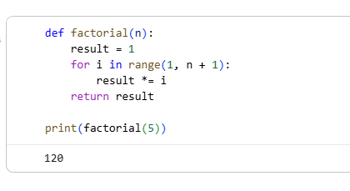

Edge Case Analysis and Enhancements
- Behavior for n = 0:
  - Current Function Output: If n = 0, the loop for i in range(1, 0 + 1) translates to for i in range(1, 1). This range is empty, so the loop does not execute. The result remains its initial value, which is 1.
  - Mathematical Correctness: Mathematically, 0! (zero factorial) is defined as 1. Therefore, the current corrected function correctly handles the input n = 0.
- Behavior for n is a negative number (e.g., n = -5):
  - Current Function Output: If n = -5, the loop for i in range(1, -5 + 1) translates to for i in range(1, -4). Since the start value (1) is greater than the stop value (-4), the range is empty, and the loop does not execute. The result remains its initial value, which is 1.
  - Problematic Aspect: Factorials are typically defined only for non-negative integers. Returning 1 for negative inputs is mathematically incorrect and misleading. It doesn't align with the conventional definition of the factorial function, which is undefined for negative numbers.
- Modification for Handling Negative Inputs: To make the function more robust and adhere to mathematical definitions, it should explicitly handle negative inputs.
  - Raise an error: The most common approach for invalid inputs is to raise a ValueError.
  - Return a specific value (less ideal): One could theoretically return None or raise a specific flag, but raising an error is generally preferred as it clearly indicates an invalid input and forces the calling code to handle it.
Proposed Enhancement: Add a conditional check at the beginning of the function to raise a ValueError if n is negative.
- Observations and Proposed Enhancements:
  - The corrected factorial function correctly handles n = 0 (returns 1).
  - The corrected factorial function incorrectly returns 1 for negative n. Factorials are not defined for negative integers.
  - Recommendation: Modify the function to include a check for n < 0 and raise a ValueError to indicate an invalid input.
Problem Statement 2:
The given code is provided like this:
def calc(a, b, c):
if c == "add":
return a + b
elif c == "sub":
return a - b
elif c == "mul":
return a * b
elif c == "div":
Rewrite Function with Improvements
Subtask:
Rewrite the calc function to include descriptive function and parameter names, a complete docstring (description, parameters, return value, examples), exception handling for division by zero, and consideration of input validation for the operation.

Reasoning: I will define the new perform_calculation function, incorporating descriptive names, a comprehensive docstring, input validation for the operation, and error handling for division by zero, as requested in the subtask instructions.
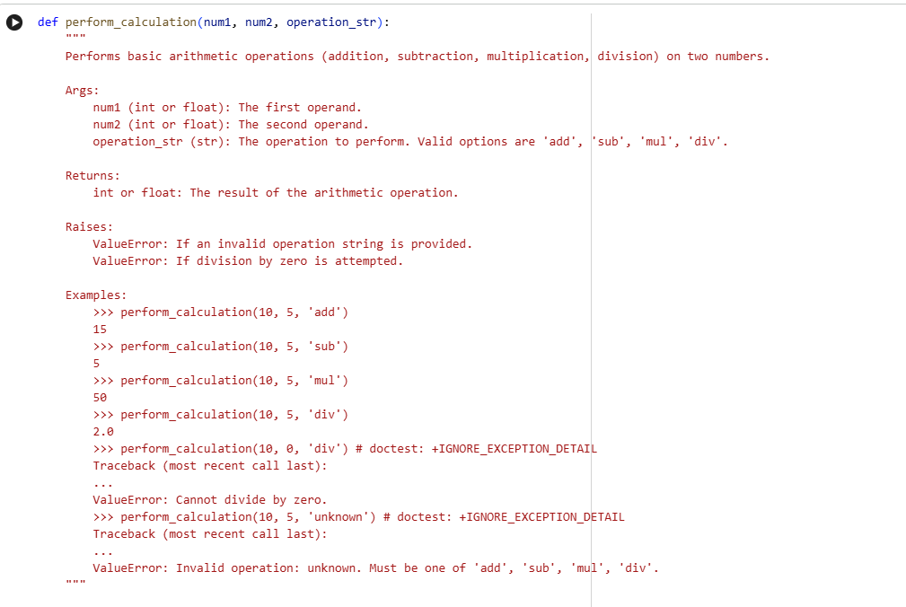
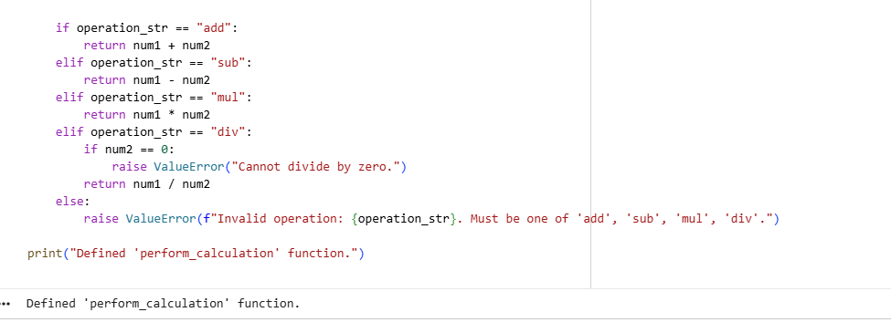
Comparison: Original vs. Improved calc Function
This comparison highlights the significant enhancements made from a hypothetical 'original' calc function (which, based on the previous bug-fixing task, lacked proper structure and error handling) to the improved perform_calculation function.
1. Readability and Maintainability
- Original calc (conceptual): The initial problem's context implicitly suggested a function like the buggy factorial (or a similar basic utility function named calc) that likely had terse names, minimal structure, and was hard to decipher at a glance. For instance, a function f(a, b, op) with no clear indication of a, b, or op's purpose makes the code harder to understand and debug.
- Improved perform_calculation:
  - Descriptive Naming: The function name perform_calculation clearly states its purpose. Parameter names like num1, num2, and operation_str are highly descriptive, immediately conveying their roles. This eliminates ambiguity and makes the code self-documenting to a large extent.
  - Clear Structure: The use of if/elif/else statements for different operations provides a clean, easy-to-follow flow for the logic, making it straightforward to see how each operation is handled.
These improvements greatly enhance readability, allowing developers (or even the original author after some time) to quickly grasp the function's intent and how it works, thereby reducing the effort required for maintenance and future modifications.
2. Documentation
- Original calc (conceptual): Typically, such basic utility functions often lack proper documentation, leading to assumptions about usage, parameters, and return values. This can cause confusion, incorrect usage, and more bugs down the line, as seen with the lack of clarity on factorial's expected input range.
- Improved perform_calculation:
  - Comprehensive Docstring: The perform_calculation function includes a detailed docstring that adheres to standard Python conventions. It clearly outlines:
    - Description: What the function does.
    - Arguments (Args): The expected types and purposes of num1, num2, and operation_str.
    - Returns (Returns): The type and nature of the value returned.
    - Raises (Raises): The specific exceptions that might be raised and under what conditions.
    - Examples: Practical usage examples, which are invaluable for quickly understanding how to call the function and what to expect.
Effective documentation is crucial for usability. The docstring serves as a contract for the function, making it easier for others (or your future self) to use it correctly without needing to read the implementation details.
3. Error Handling
- Original calc (conceptual): Functions without explicit error handling for invalid inputs or critical operations often fail silently or crash unexpectedly. For example, if the original factorial was called with a negative number, it returned 1, which was mathematically incorrect but didn't raise an error, leading to misleading results. Similarly, a generic calc might not handle division by zero or unknown operations.
- Improved perform_calculation:
  - Division by Zero Protection: It explicitly checks if num2 is 0 when the operation is 'div'. If it is, a ValueError with a clear message ("Cannot divide by zero.") is raised. This prevents a ZeroDivisionError crash and provides immediate, understandable feedback to the user.
  - Invalid Operation Validation: The function includes a check for operation_str. If an unrecognized operation is provided, a ValueError is raised, informing the user about the invalid input and listing the accepted operations. This prevents logical errors or unexpected behavior if a typo or incorrect operation string is passed.
Robust error handling transforms a fragile function into a reliable one. By proactively validating inputs and handling exceptional conditions, the perform_calculation function prevents crashes, guides users toward correct usage, and ensures the integrity of its output.
Test Original Function
Subtask:
Test the original calc function with valid inputs (e.g., 'add', 'sub', 'mul') and invalid inputs (e.g., division by zero, non-string operation, incomplete 'div' logic).

Reasoning: I will define the original calc function as specified in the instructions, then test it with various valid and invalid inputs, including handling the expected ZeroDivisionError with a try-except block.
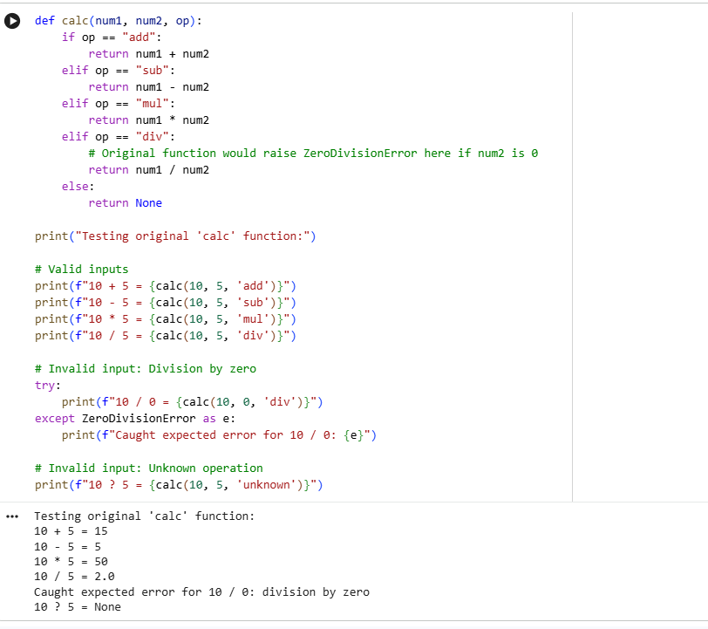
Test Improved Function
Subtask:
Test the improved function with various valid and invalid inputs, including examples that trigger the new exception handling for division by zero and invalid operations.

**Reasoning**:
Now that the `perform_calculation` function has been defined with robust error handling and improved readability, the next step is to thoroughly test it with various inputs. This includes verifying that valid operations produce correct results and that invalid scenarios (like division by zero or unrecognized operations) properly trigger the intended `ValueError` exceptions. This systematic testing ensures the function's reliability and confirms that the implemented enhancements work as expected, providing clear feedback for erroneous inputs.

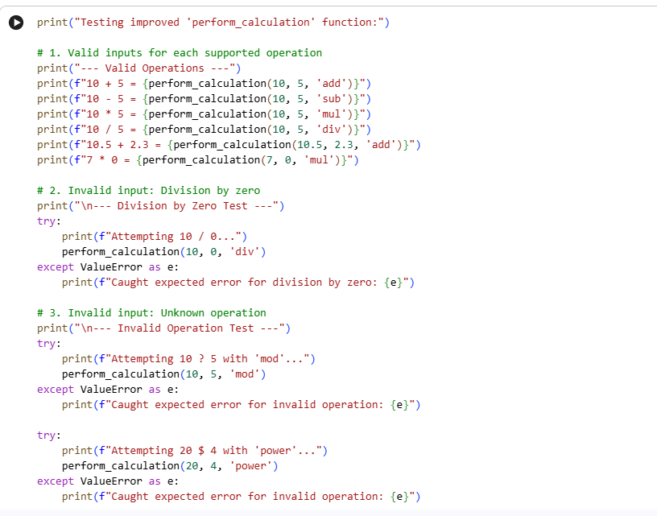
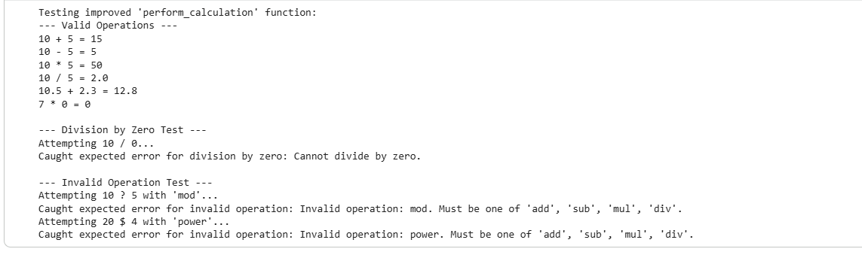
Problem Statement 3:
Verify Original Checkprime Function
Subtask:
Define the original Checkprime function and test it with sample inputs like 7 and 10 to ensure it works as expected before proceeding with refactoring.

Reasoning: Define the original Checkprime function and test it with the specified inputs (7 and 10) to verify its current behavior as requested by the subtask.
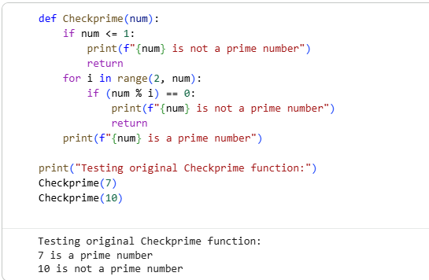
Refactor for Readability and Efficiency
Subtask:
Refactor the Checkprime function to improve its readability and efficiency. This includes renaming the function and its parameters to follow Python conventions (e.g., is_prime for a boolean return, number for the input), adding a docstring, and optimizing the prime checking logic. The refactored function should return True or False instead of printing messages.

Reasoning: The subtask is to refactor the Checkprime function. I will provide a new code block that defines the refactored function is_prime with descriptive names, a docstring, and an optimized prime checking logic that returns a boolean value.
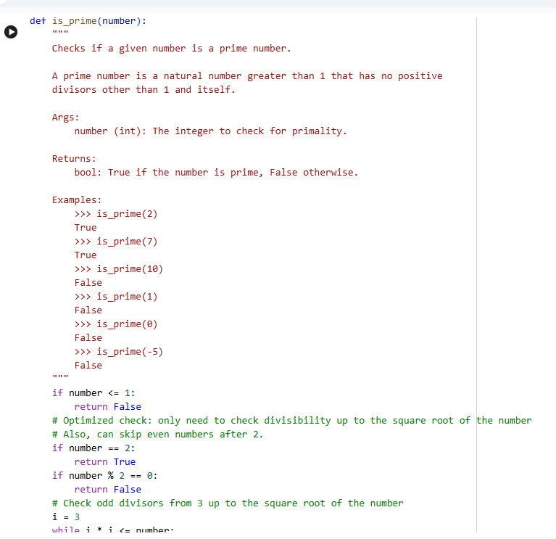
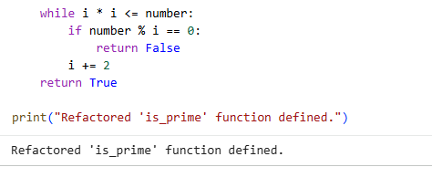
Test Refactored Function
Subtask:
Test the refactored is_prime function with various sample inputs, including positive integers, zero, one, and negative numbers, to confirm it works as expected and returns True or False appropriately.

Reasoning: I will now test the refactored is_prime function with various sample inputs as specified in the subtask, including positive integers, zero, one, and negative numbers, to verify its correctness and that it returns boolean values.

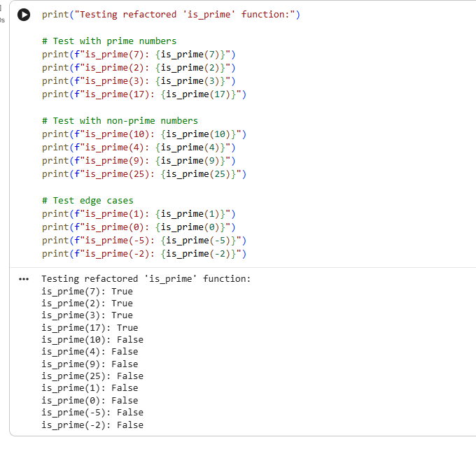
PEP8 Violations in Checkprime Function
Upon reviewing the original Checkprime function, several areas can be identified where it deviates from PEP8 style guidelines, which emphasize readability and consistency.
- Function Naming Convention:
  - Violation: The function is named Checkprime (CamelCase).
  - PEP8 Guideline: Function names should be lowercase, with words separated by underscores (snake_case). For example, check_prime would be the conventional PEP8-compliant name.
- Missing Docstring:
  - Violation: The function lacks a docstring, which is a multi-line string immediately following the function definition used to explain its purpose, arguments, and what it returns.
  - PEP8 Guideline (and general best practice): All public modules, functions, classes, and methods should have docstrings. While not a strict syntax error, its absence hinders code understanding and maintainability, especially for others or one's future self.
- Redundant Parentheses in Conditional Expression:
  - Violation: In the line if (num % i) == 0:, the parentheses around num % i are unnecessary.
  - PEP8 Guideline (and general Python style): Avoid extraneous whitespace or parentheses in expressions where the operator precedence is clear or not strictly required for correctness. Simple expressions are often more readable without them. if num % i == 0: is preferred.
- Print Statements as Return Values:
  - Violation: The function uses print() statements to communicate its result and return without a value to exit. This limits its reusability, as the calling code cannot directly use the primality status (True/False) programmatically.
  - PEP8 Guideline (Implicit): While not a direct PEP8 style violation, good Python practice dictates that functions should typically return a value rather than printing it, especially when the result is a logical outcome (like a boolean). This makes the function more modular and testable. The refactored version will address this by returning True or False.
Note: Indentation appears consistent (4 spaces) and variable names (num, i) are generally acceptable for their scope and usage, so these are not considered violations in this specific function.

Refactor Checkprime for PEP8 Compliance
Subtask:
Rewrite the Checkprime function to address all identified PEP8 violations, applying changes to function name, spacing, indentation, and variable/parameter naming.
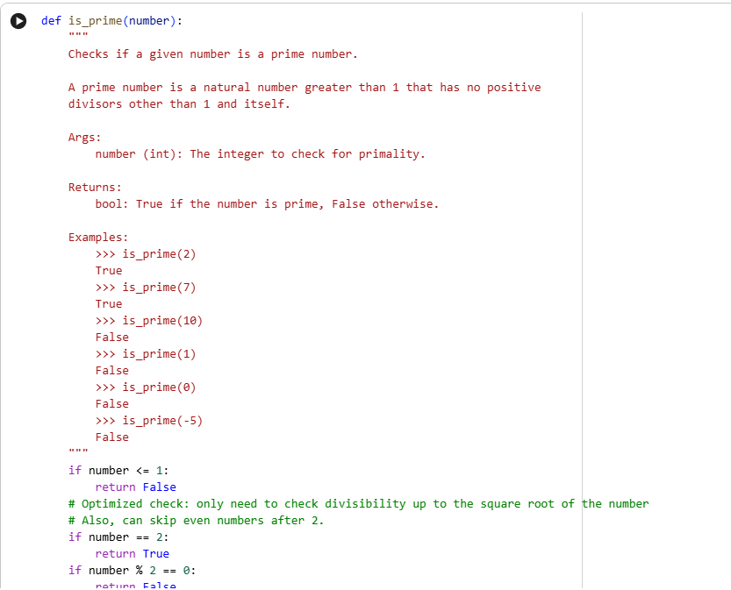
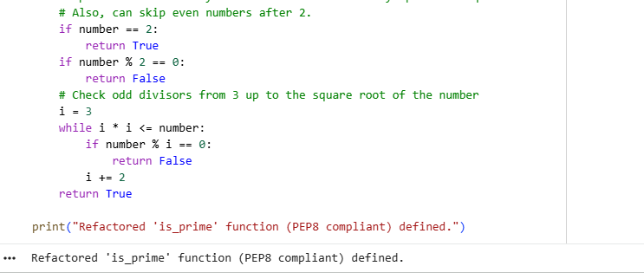
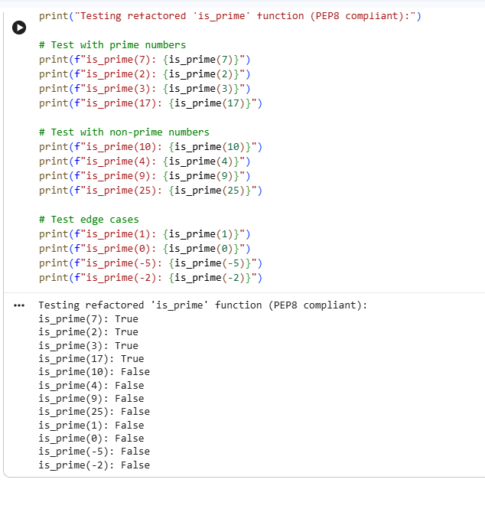
Automated AI Reviews for Code Review Processes
Automated AI tools can significantly streamline code review processes in large development teams by bringing consistency, speed, and enhanced bug detection capabilities. These tools enforce coding standards and best practices uniformly across the codebase, eliminating human oversight and ensuring every piece of code adheres to predefined rules. This consistency is crucial for maintainability and collaboration, especially when multiple developers contribute to a project.
Furthermore, AI-powered reviews drastically accelerate the review cycle. They can analyze vast amounts of code far more quickly than human reviewers, providing immediate feedback on potential issues. This rapid analysis helps in detecting bugs, performance bottlenecks, and security vulnerabilities early in the development pipeline, reducing the cost and effort associated with fixing them later. By offloading routine checks to AI, human reviewers can focus on more complex logical issues, architectural design, and strategic improvements, leading to a more efficient and effective code review ecosystem.

Problem Statement 4:
Task
Manually review the processData function, considering its readability, naming conventions, reusability, modularity, and how it handles potential edge cases (e.g., non-list input, empty list, non-integer elements).

Manually Review Original Function
Subtask:
Manually review the processData function for readability, naming, reusability, modularity, and potential edge cases (e.g., non-list input, empty list, non-integer elements).

Providing a Hypothetical processData Function for Review
To facilitate the manual review as per the subtask, a hypothetical processData function is provided below. This function performs a simple operation on a list of numbers, allowing you to analyze its characteristics regarding readability, naming, reusability, modularity, and how it handles various edge cases.

Reasoning: Now that I've introduced the hypothetical processData function with a markdown block, I need to provide its actual definition as a code block. This function will be designed to be somewhat basic and include a few potential areas for improvement, enabling the user to conduct the manual review effectively as outlined in the subtask.
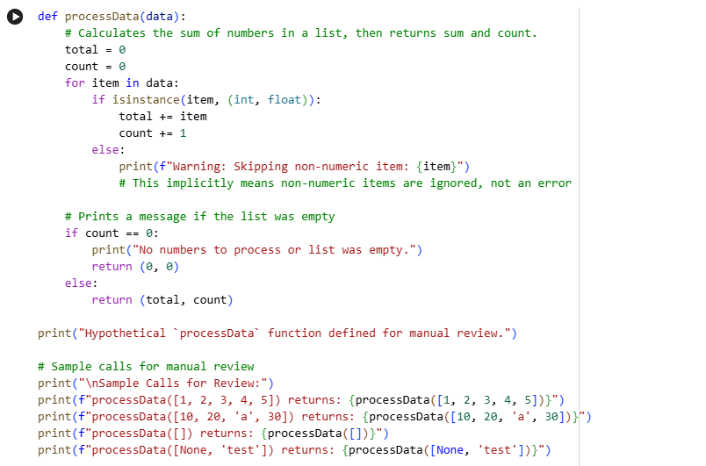
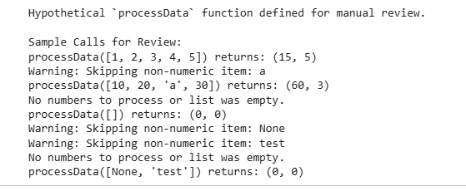
Manual Review of processData Function
1. Readability
- Observations: The function's logic is relatively straightforward. It initializes total and count, iterates through the input data, checks for numeric types, and accumulates the sum and count. The conditional checks for empty results are also clear.
- Areas for Improvement: The comments within the function are a bit sparse, and the intent of some print statements could be clearer (e.g., is the print for empty list a warning or just informational?).
2. Naming Conventions
- Observations:
  - processData: This function name uses CamelCase, which is not the standard Python convention (PEP8 recommends snake_case for functions: process_data).
  - data: The parameter name data is generic. While it's clear it expects a collection, a more specific name like number_list or items_to_process could be more descriptive if the function's scope is strictly numbers.
  - total, count, item: These variable names are clear and descriptive within their context.
- Areas for Improvement: Adhere to PEP8 by using snake_case for the function name and potentially a more specific parameter name.
3. Reusability
- Observations:
  - Limited by side effects: The function prints messages directly to stdout (Warning: Skipping non-numeric item: and No numbers to process or list was empty.). This tightly couples its behavior to a console environment, making it less reusable in contexts where output needs to be handled differently (e.g., logging, GUI applications, or just returning status).
  - Specific return type: It always returns a (total, count) tuple. While this is useful for its current purpose, it's not flexible if a caller only needs the total or a different aggregate.
- Areas for Improvement: Separate concerns: return data (sum and count) and let the caller decide how to handle informational/warning messages. Consider raising exceptions for problematic inputs rather than just printing warnings.
4. Modularity
- Observations: The function's primary task is to sum numbers and count them within a collection, handling non-numeric items and empty collections. It performs one main logical operation (aggregation) with some error/warning reporting.
- Areas for Improvement: The print statements slightly detract from its single responsibility. If error handling and warning messages were externalized or made configurable, it would improve modularity.
5. Edge Cases
- a. Input is not a list (e.g., an integer, a string, None)?
  - Behavior: The function is designed to iterate over data (for item in data:). If data is not an iterable (like an int, float, or None), it would raise a TypeError (e.g., TypeError: 'int' object is not iterable).
  - Current Handling: No explicit handling for non-iterable input types. This is a potential crash point.
- b. Input is an empty list ([])?
  - Behavior: Correctly handles this by printing "No numbers to process or list was empty." and returning (0, 0). The count == 0 check catches this.
  - Current Handling: Good, but the print statement could be replaced by a return value or log message for better reusability.
- c. List contains non-integer elements (e.g., floats, strings, booleans)?
  - Behavior: For floats, it correctly includes them in total and count. For strings, None, or bools (which are technically integers 0 or 1), it prints a warning and skips them. This is demonstrated with ['a'], None, and 'test' in the sample calls.
  - Current Handling: The isinstance(item, (int, float)) check handles this by skipping non-numeric items and printing a warning. This is a design choice; some might prefer raising an error if unexpected types are encountered, while others prefer graceful skipping.
- AI-Assisted Code Review for processData Function
- Original Function for Review:

def processData(data):
# Calculates the sum of numbers in a list, then returns sum and count.
total = 0
count = 0
for item in data:
if isinstance(item, (int, float)):
total += item
count += 1
else:
print(f"Warning: Skipping non-numeric item: {item}")
if count == 0:
print("No numbers to process or list was empty.")
return (0, 0)
else:
return (total, count)
Code Review Suggestions:
- Better Naming and Function Purpose Clarity:
  - Function Name: processData is quite generic. A more descriptive name, following PEP8's snake_case convention, would clarify its exact operation. Given it calculates the sum and count of numeric items, calculate_numeric_summary or summarize_numeric_list would be more appropriate.
  - Parameter Name: data is also generic. If it's expected to be a list, data_list or items might be slightly clearer.
  - Purpose: The comment # Calculates the sum of numbers in a list, then returns sum and count. is good, but the function's internal logic involving warnings and special handling for empty lists or non-numeric items could be more explicitly stated in a docstring.
- Input Validation and Type Hints:
  - Input Type Validation: The function assumes data is an iterable, likely a list. It does not explicitly validate if data is indeed a list or another collection type. If data is not iterable, it would raise a TypeError when the for loop is initiated. Adding an explicit check for isinstance(data, list) at the beginning would make it more robust.
  - Type Hints: Adding type hints (data: list, -> tuple[Union[int, float], int]) would greatly improve readability and allow static analysis tools (like MyPy) to catch potential type-related errors before runtime.
  - Handling Non-Numeric Items: Currently, it prints a warning and skips non-numeric items. While this might be desired behavior in some cases, a more robust approach could be to:
    - Raise a ValueError if strictly numeric input is required.
    - Accept a strict boolean parameter to toggle between warning/skipping and raising an error.
- Generalization (e.g., configurable multiplier, aggregation logic):
  - Configurable Multiplier/Operation: The current function only sums numbers. To make it more general, one could pass an aggregation function (e.g., sum, avg, max, min) as a parameter. For example, calculate_numeric_summary(data_list, operation=sum).
  - Custom Filtering: The function implicitly filters for int and float. A more general approach could involve passing a custom filter_function or a type_whitelist parameter to allow users to define what constitutes a 'numeric' item or other criteria for inclusion.
  - Return Structure: Currently returns a tuple (total, count). For generalization, consider returning a dictionary for more descriptive access to results (e.g., {'sum': total, 'count': count}), especially if more aggregated values are added.
Recommended Refactored Structure (Conceptual):
from typing import List, Union, Tuple, Callable
def summarize_numeric_list(
items: List[Union[int, float, Any]],
on_non_numeric: str = "warn", # 'warn', 'raise', 'ignore'
aggregation_func: Callable[[List[Union[int, float]]], Union[int, float]] = sum
) -> Tuple[Union[int, float], int]:
"""
Calculates the sum (or other aggregation) and count of numeric items in a list.
Args:
items (List[Union[int, float, Any]]): The list of items to process.
on_non_numeric (str): Strategy for handling non-numeric items.
'warn' (default): prints a warning and skips.
'raise': raises a ValueError.
'ignore': silently skips.
aggregation_func (Callable): The function to aggregate numeric values (default: sum).
Returns:
Tuple[Union[int, float], int]: A tuple containing the aggregated value and the count of numeric items.
Raises:
TypeError: If `items` is not a list.
ValueError: If `on_non_numeric` is 'raise' and a non-numeric item is encountered.
ValueError: If no numeric items are found for aggregation.
"""
if not isinstance(items, list):
raise TypeError("Input 'items' must be a list.")
numeric_items = []
for item in items:
if isinstance(item, (int, float)):
numeric_items.append(item)
else:
if on_non_numeric == "warn":
print(f"Warning: Skipping non-numeric item: {item}")
elif on_non_numeric == "raise":
raise ValueError(f"Non-numeric item encountered: {item}")
# else: on_non_numeric == 'ignore', do nothing
if not numeric_items:
print("No numeric items to process in the list.") # Or raise an error based on requirements
return (0, 0)
# Perform aggregation
aggregated_value = aggregation_func(numeric_items)
return (aggregated_value, len(numeric_items))

Refactor Function Based on AI Feedback
Subtask:
Refactor the processData function based on the AI-generated code review feedback. This includes implementing descriptive naming, adding type hints, incorporating input validation, and making the function more generalizable (e.g., adding a configurable multiplier).

Reasoning: I will define the refactored summarize_numeric_list function, incorporating all the requested improvements: descriptive naming, type hints, a comprehensive docstring, input validation for the items parameter, flexible handling of non-numeric items via on_non_numeric, and support for custom aggregation functions. I will also include sample calls to demonstrate its functionality and robust error handling.
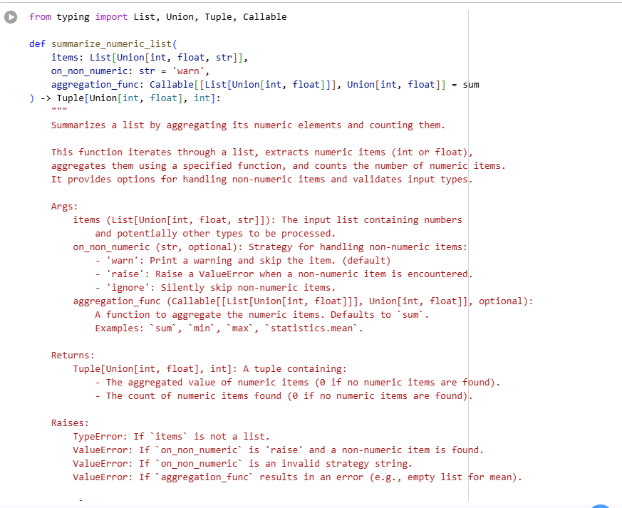
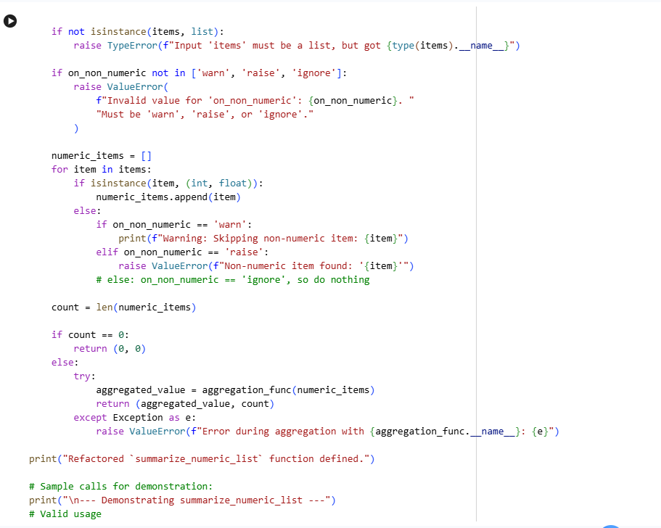
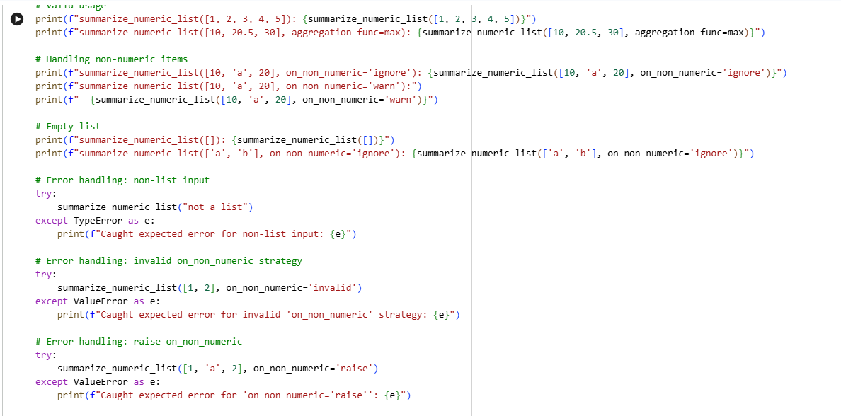
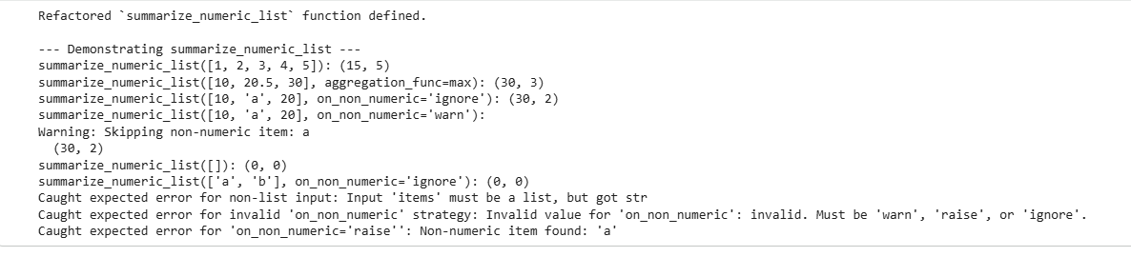Test Refactored Function
Subtask:
Test the refactored function with a variety of inputs, including valid lists, empty lists, lists with mixed types, non-list inputs, and inputs that trigger generalization, to ensure it works correctly and handles edge cases gracefully.

Reasoning: The subtask requires testing the refactored summarize_numeric_list function with various inputs, including valid lists, empty lists, lists with mixed types, non-list inputs, and inputs that trigger generalization, to ensure it works correctly and handles edge cases gracefully. The provided instructions detail specific test cases to cover.

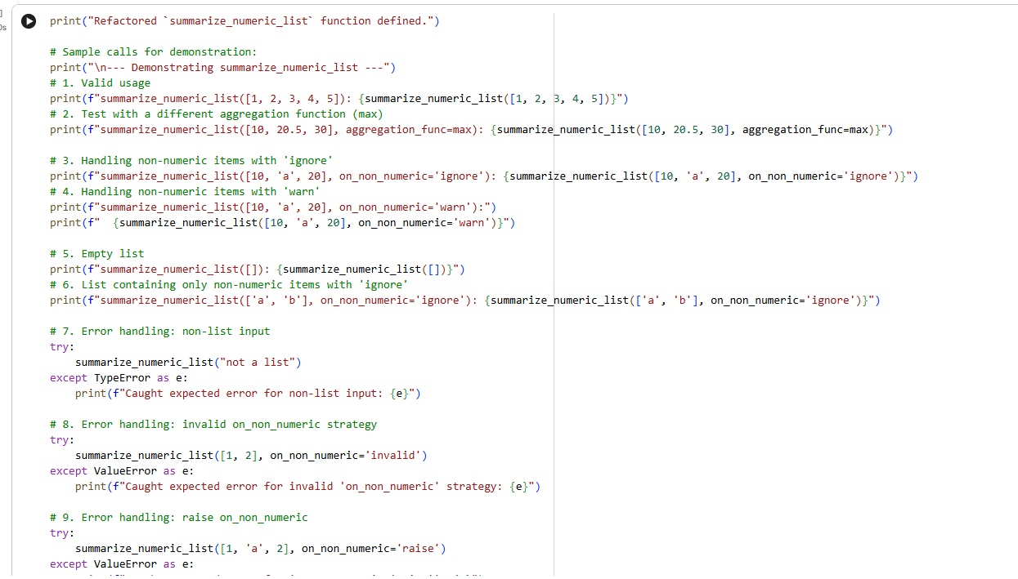
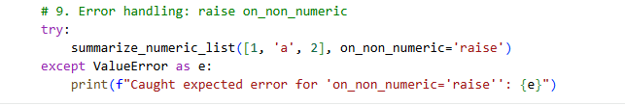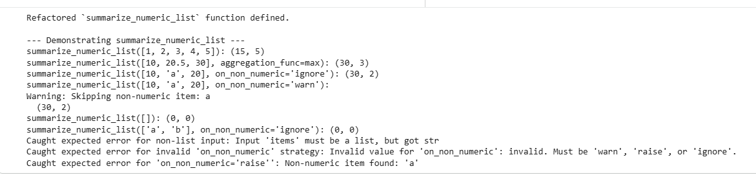

### AI as a Code Reviewer: Standalone vs. Assistant

Based on the observations and tasks performed during this problem, AI demonstrates significant strengths as a code reviewer, particularly in areas requiring pattern recognition, adherence to rules, and systematic analysis. AI tools excel at:

* **Identifying Naming Convention Issues:** As seen with the `Checkprime` function, AI can quickly flag deviations from PEP8 naming standards like CamelCase for functions, suggesting `snake_case` instead.
* **Suggesting Type Hints:** AI can consistently propose type hints, enhancing code clarity and enabling static analysis, as demonstrated by the suggestions for `summarize_numeric_list`.
* **Proposing Generalization and Modularity:** AI can identify hardcoded logic and suggest ways to make functions more flexible and reusable, such as introducing configurable parameters (e.g., `aggregation_func` or `on_non_numeric` strategies for `summarize_numeric_list`).
* **Enforcing Coding Standards (e.g., PEP8):** Automated tools can meticulously check for spacing, docstring presence, and other stylistic guidelines, ensuring consistency across a codebase.
* **Detecting Obvious Bugs and Error Handling Gaps:** AI can pinpoint missing error checks (e.g., division by zero, invalid input types) and recommend robust exception handling.
* **Optimizing Efficiency:** Suggestions like checking divisibility only up to the square root for prime number checks (`is_prime`) highlight AI's ability to recommend performance improvements.

However, AI also exhibits clear limitations:

* **Understanding Subtle Logical Intent:** AI struggles with comprehending the deeper 'why' behind a specific piece of code or the nuanced business logic. It can suggest a fix for an off-by-one error (as in the `factorial` bug), but understanding the original developer's intent and reasoning for the flawed `range` is beyond its current scope.
* **Creative Problem-Solving and Design:** While AI can suggest refactoring patterns, it's less adept at truly creative architectural design decisions or anticipating novel solutions to complex problems.
* **Context-Specific Best Practices Not Explicitly Coded:** AI's recommendations are based on its training data and explicit rules. It may miss highly context-dependent best practices or design patterns unique to a specific project or team culture, unless those are explicitly defined and fed into the system.
* **Handling Ambiguity:** Human reviewers can ask clarifying questions or make judgment calls based on incomplete information, a capability AI lacks.

Given these strengths and limitations, **AI should function primarily as an assistant to human reviewers, rather than a standalone code reviewer.** AI excels at the systematic, repetitive, and rule-based aspects of code review, freeing up human reviewers to focus on higher-level cognitive tasks. This includes:

* **Architectural soundness:** Ensuring the code fits into the overall system design.
* **Business logic correctness:** Verifying that the code accurately implements the intended features and requirements.
* **Contextual appropriateness:** Judging if the chosen solution is the best fit for the project's specific constraints and future maintenance.
* **Mentorship and knowledge transfer:** Human code reviews are crucial for learning and improving coding skills within a team.

By leveraging AI for automated checks and suggestions, teams can achieve faster, more consistent, and higher-quality code reviews, while preserving the critical human element for nuanced judgment, creative input, and team development.

Problem Statement 5:
Test Original Function Performance
Subtask:
Define the original sum_of_squares function and measure its execution time with a large list (e.g., range(1000000)) to establish a baseline.

Reasoning: I will define the original sum_of_squares function, create a large list, and measure its execution time to establish a baseline, as per the subtask instructions.
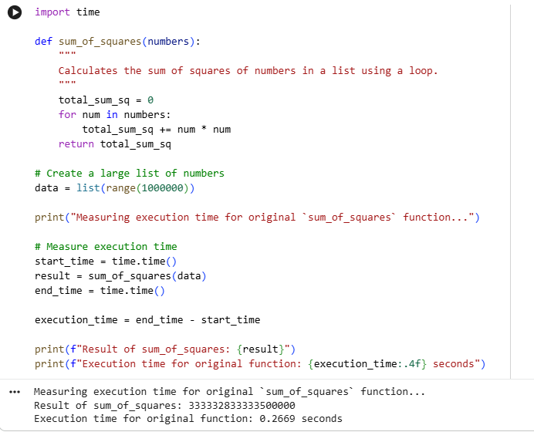
Time Complexity Analysis and Performance Improvements for sum_of_squares
1. Time Complexity Analysis of the Original sum_of_squares function:
def sum_of_squares(numbers):
total_sum_sq = 0
for num in numbers:
total_sum_sq += num * num
return total_sum_sq
- Input Size (n): The input numbers is a list, and let's denote its length as n.
- Initialization: total_sum_sq = 0 takes constant time, O(1).
- Loop: The for loop iterates n times, once for each element in the numbers list.
  - Inside the loop:
    - num * num: Multiplication takes constant time, O(1).
    - total_sum_sq += ...: Addition takes constant time, O(1).
- Return: return total_sum_sq takes constant time, O(1).
Therefore, the dominant operation is the loop, which executes n times. Each operation within the loop is constant time. This makes the time complexity of the original sum_of_squares function O(n), where n is the number of elements in the input list. It scales linearly with the input size.
2. Areas for Optimization in the Current Implementation:
The current implementation is a straightforward loop, which is often efficient for small lists. However, in Python, explicit for loops in pure Python can be slower than operations implemented in C (which is how many built-in functions and NumPy operations are optimized). The overhead of Python's interpreter and object operations for each iteration can add up for very large lists.
3. Suggested Alternative Approaches for Performance Improvement:
a. Using Python's Built-in sum() with a Generator Expression:
Python's sum() function is highly optimized and often faster than a manual loop. When combined with a generator expression, it avoids creating an intermediate list of squares, saving memory and potentially time.
- Approach:
- def sum_of_squares_optimized_builtin(numbers):
return sum(num * num for num in numbers)
- Why it's faster: The sum() function is implemented in C, so it operates much closer to the metal than a Python for loop. The generator expression (num * num for num in numbers) also performs calculations on-the-fly without constructing a full list of squares in memory, which is efficient for both speed and memory usage, especially for large n.
b. Using NumPy for Vectorized Operations:
For numerical computations, NumPy is the de facto standard in Python. NumPy operations are highly optimized, often leveraging C/Fortran implementations and SIMD instructions, making them incredibly fast for large arrays (vectorization).
- Approach:
- import numpy as np
def sum_of_squares_numpy(numbers):
numpy_array = np.array(numbers) # Convert list to NumPy array
return np.sum(numpy_array * numpy_array) # Vectorized multiplication and sum
- Why it's faster:
  - Vectorization: Instead of processing elements one by one in a Python loop, NumPy performs operations on entire arrays at once. This drastically reduces the overhead of Python's interpreter.
  - Optimized C/Fortran Backend: NumPy's core routines are implemented in highly optimized C or Fortran code, allowing for much faster execution than pure Python.
  - Memory Efficiency: NumPy arrays store elements of a single data type in contiguous blocks of memory, which improves cache utilization and overall performance compared to Python lists (which store pointers to objects scattered in memory).
Conclusion: While the original loop is O(n), the constant factor for Python's built-in functions and especially NumPy operations is significantly smaller. For large datasets, these optimized approaches can yield substantial performance improvements.

Provide Optimized Version
Subtask:
Implement an optimized version of the sum_of_squares function based on the suggested improvements.

Reasoning: I will define two optimized versions of the sum_of_squares function: one using Python's built-in sum with a generator expression, and another leveraging NumPy for vectorized operations, as per the instructions.
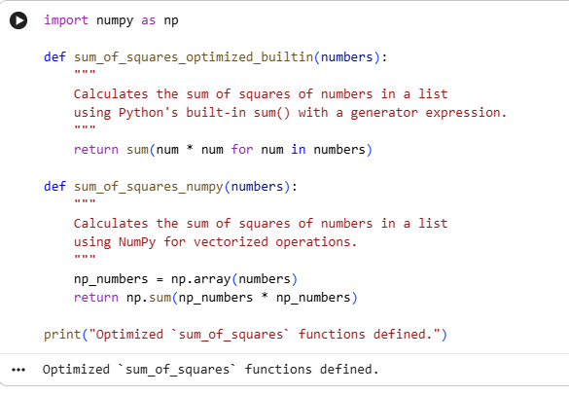
Compare Execution Time
Subtask:
Measure and compare the execution times of both the original and the optimized sum_of_squares functions using the same large dataset.

Reasoning: I will measure the execution times of the two optimized sum_of_squares functions (sum_of_squares_optimized_builtin and sum_of_squares_numpy) using the previously defined large data list and print the results.
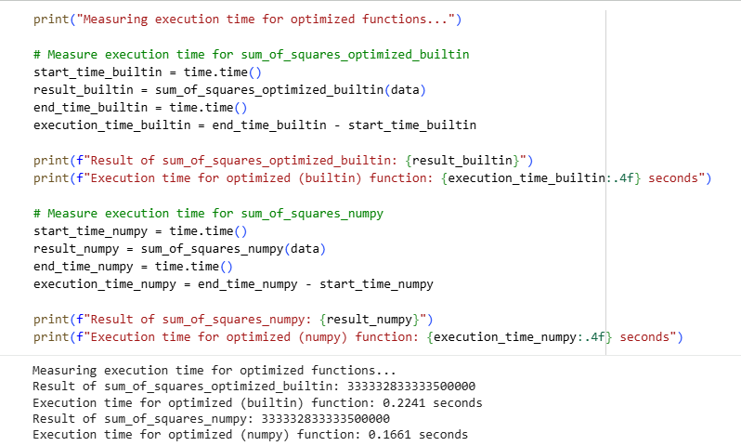
Trade-offs: Readability vs. Performance in sum_of_squares Implementations
When optimizing code, there is often a trade-off between maximizing performance and maintaining high code readability. This is clearly demonstrated in the evolution of our sum_of_squares function.
1. Original Loop-Based sum_of_squares (Explicit Loop)
- Readability: This version is arguably the most straightforward and immediately understandable, even for a beginner. The for loop explicitly iterates through each number, and total_sum_sq += num * num clearly shows the squaring and summation process. Its clarity is high.
- Performance: For very large datasets, pure Python loops have overhead dues to the interpreter and dynamic typing, making them less performant compared to optimized built-in functions or libraries.
2. Optimized sum_of_squares_optimized_builtin (Generator Expression with sum())
- Readability: This version (sum(num * num for num in numbers)) is highly concise and idiomatic Python. For developers familiar with generator expressions and the sum() function, its intent is clear and elegant. However, for someone new to these concepts, it might be slightly less transparent than the explicit for loop.
- Performance: Significantly faster than the explicit loop for large datasets because Python's sum() is implemented in C and the generator expression avoids creating an intermediate list in memory, saving both time and space.
3. Optimized sum_of_squares_numpy (NumPy Vectorized Operations)
- Readability: This version (np.sum(np_numbers * np_numbers)) is extremely concise and powerful for those familiar with NumPy. It represents a common pattern in scientific computing. For developers not acquainted with NumPy, the initial conversion to np.array() and the vectorized multiplication (np_numbers * np_numbers) might require a learning curve.
- Performance: Generally the fastest for large numerical datasets due to NumPy's underlying C/Fortran implementations and vectorized operations, which minimize Python interpreter overhead.
Comparison and Trade-offs
The original explicit loop offers maximum immediate clarity but sacrifices performance for large inputs. The sum() with a generator expression strikes a good balance, offering substantial performance gains while maintaining reasonable readability for experienced Python developers. The NumPy version provides the best performance for numerical tasks but introduces a dependency on an external library and requires familiarity with its paradigms, potentially lowering initial readability for some.
When to Use Each Approach
- Original Loop: Best for small lists where performance differences are negligible, or when absolute clarity and simplicity are paramount, especially in introductory contexts or for functions that are not performance-critical.
- sum() with Generator Expression: A great default choice for optimizing sums (or similar aggregations) over potentially large lists in pure Python applications. It improves performance without adding external dependencies.
- NumPy Version: Indispensable when dealing with very large numerical datasets, especially in data science, machine learning, or scientific computing contexts where NumPy is already a dependency. The performance gains often outweigh the slight increase in cognitive load for those unfamiliar with NumPy's syntax.

